מגישים: שחר פטרן 318867272, דביר כהן 207171232

מחלקות יורשות בלוגיקה:

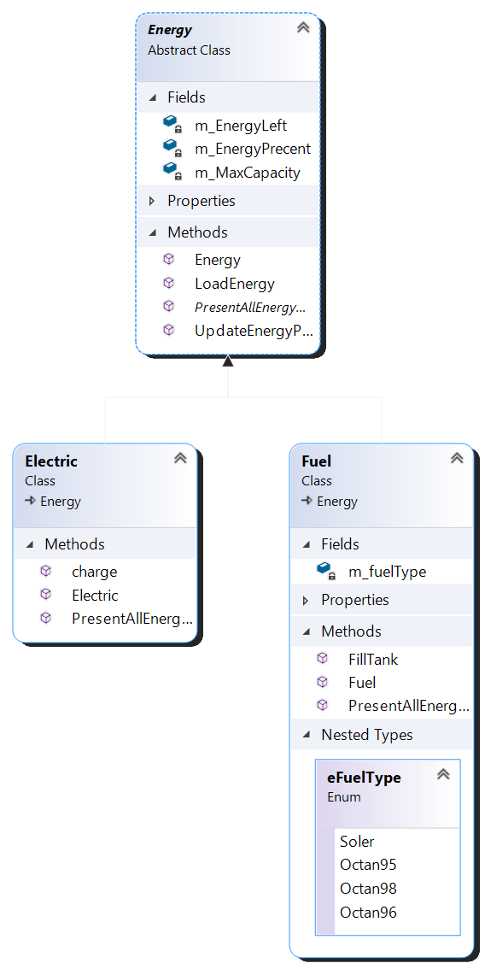

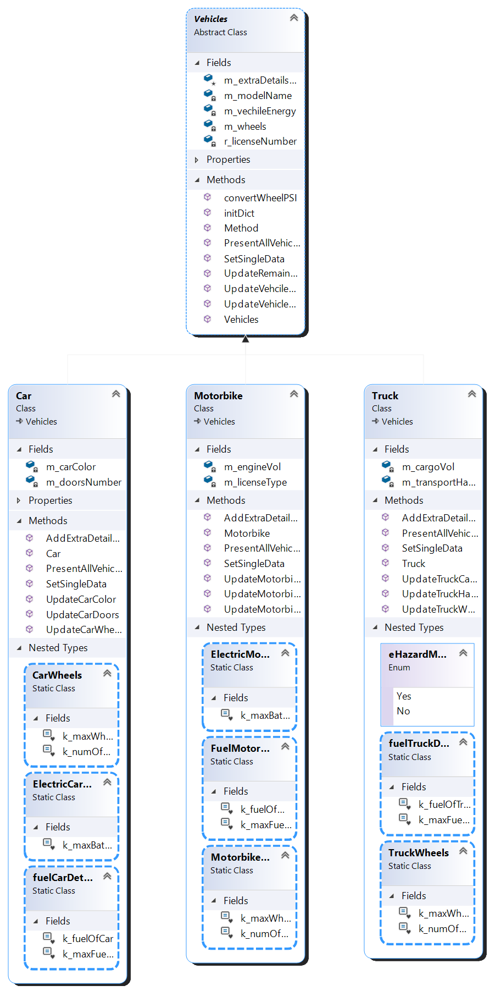

עומדות לחוד בלוגיקה

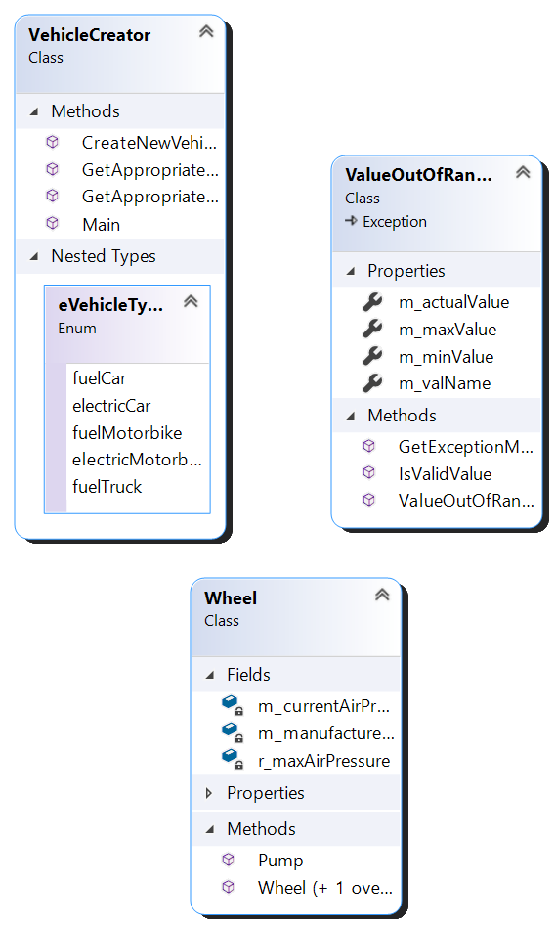

מחלקות בUI

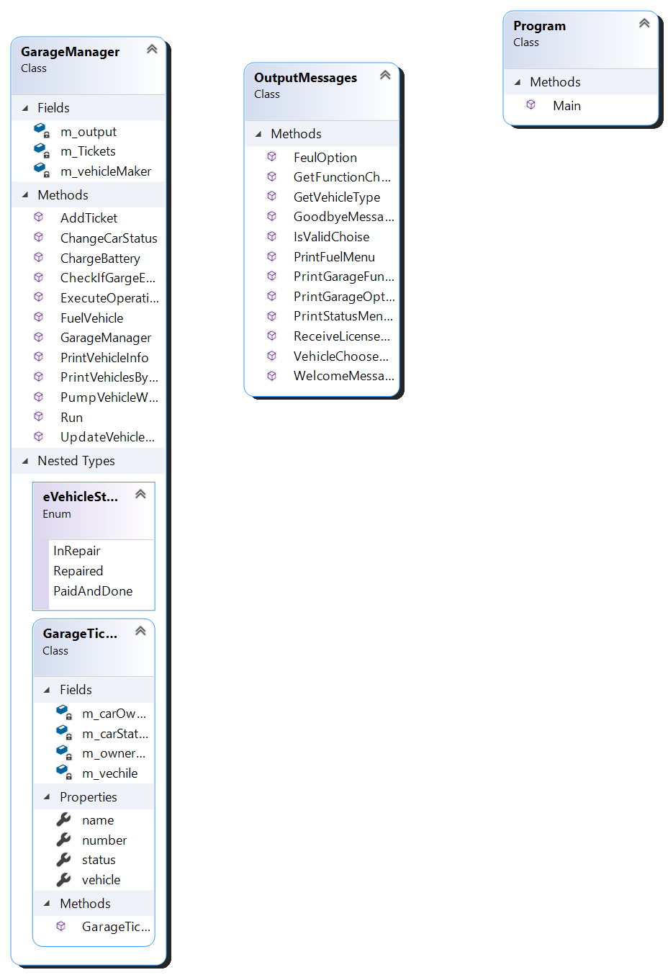

Classes:

Vehicles –holds the simple attribute of any kind of vehicle.

Base class for Car, Truck, Motorbike.

Car – holds data members: doors number and color. Derive class from Vehicle.

Motorbike – holds data members: license type and engine volume. Derive class from Vehicle.

Truck – holds data members: cargo volume and transportation of hazardous materials. Derive class from vehicle.

Energy – abstract class, holds basic information and methods of any kind of energy.

Electric,Fuel – derive classes of Energy, has the kind of gas in case of Fuel and more extra details.

VehicleCreator – create any kind of vechicle(Motorbike, Car or Truck).

Wheel – holds information about any single wheel and the ability to pump the wheel.

ValueOutOfRange – new exception class that inherit from the exception class. This class throw exception in case of value that out of range in many scenarios.

OutPutMessages – this class print messages to the console.

GarageManager – this class save any tickets of vehicle in the garage and manage the progression of the system.

Program – this class holds the Main function to run the olution.